The investigation and 3D numerical simulation of herb roots in reinforcing soil and stabilizing slope

Yang Yang $​^{1}$

Wang Jinxia $​^{3}$

Duan Qingsong $​^{2*}$

Su Chao $​^{1}$

Yan Mingjiao $​^{4}$

Dong Yijia $​^{1}$

Received: date / Accepted: date

# Introduction

Vegetation has been widely used in reinforcing soil and stabilizing slope . In hillslopes, riverbanks and artificial slopes stabilization, the use of ecological engineering techniques has been a successful alternative to civil engineering solutions .

The stability of the slope is enhanced by plant in terms of mechanical and hydrological mechanisms . At present, most studies mainly focus on the mechanical effect of roots on the reinforcement soils , the principal mechanism by which plant roots reinforce soil is the tensile strength provided by the root network .

To evaluate the mechanical effect of roots on reinforcement soils, researchers presented some root reinforced models to estimate the additional root cohesion (additional shear strength). The widely used is the simple perpendicular root model of Wu/Waldron (WWM) . WWM evaluates additional root cohesion via root tensile strength and the cross-sectional area of fibers crossing the shear plane (RAR). However, the WWM model overestimates the additional root cohesion, because WWM assumes that all roots system break simultaneously. In reality, as a soil-root matrix, the roots contained within the soil have different tensile strengths and thus break progressively, with an associated redistribution of stress as each root breaks . Hence the individual roots are stretched, pulled out and break.

In order to describe the process of progressive failure, applied a fiber bundle model (FBM) to estimate the additional root cohesion. The principle of FBM is that the maximum load for a bundle fiber is less than the sum of each of their individual strengths. shows that the use of FBM can provide more accurate representations of shearing resistance due to roots.

The mechanical effect of plant roots has been studied both simulations and experiments on the reinforcement soils, while hydrological effect has not yet been fully investigated. The hydrological role of vegetation in slope stabilization consists of reducing the amount of water in the soil and thus increasing the soil matric suction effect, which is highly stabilizing particularly in fine soils .

Plant can stabilized slope by inducing soil suction. Plant roots absorb moisture through photosynthesis and respiration, which, as a result, desiccates the soil surrounding the plant roots and hence induces soil suction.

The stability conditions of these slopes depend on the mechanical reinforcement provided by the plant roots to the soil and on the soil suction regime in the saturated soils, which in turn is also influenced by root water uptake .

The aim of this study is to investigate the hydrological and mechanical effect on the slope stability.

# Methodology

## Infinite slope model

For many rainfall-induced landslides, the failure surfaces are often shallow and parallel to the slope surface. The infinite slope model serves as an excellent illustration for slope stability analysis . present a generalized framework for the stability of infinite slopes under steady unsaturated seepage conditions. This framework allows the water table to be located at any depth below the ground surface and variation of soil suction and moisture content above the water table under steady infiltration conditions. The schematic diagram of infinite slope is shown in Fig. [fig:sm]. The factor of safety ($F_{s}$) of a slope is evaluated as fellows:

$$F=\frac{c_{s}+(γzcos^{2}β−σ^{s})tanϕ^{′}}{γzsinβcosβ}$$

where $c_{s}$ is the soil effective cohesion; $γ$ is the soil specific weight of soil; $z$ is the depth of soil; $β$ is the slope angle; $σ^{s}$ is the suction stress characteristic curve; $ϕ$ is the effective soil friction angle.

The suction stress can be expressed in terms of normalized volumetric water content or degree of saturation as :

$$σ^{s}=−\frac{θ−θ_{r}}{θ_{s}−θ_{r}}(u_{a}−u_{w})$$

where $θ$ is the volumetric water content, $θ_{r}$ is the residual volumetric water content; $θ_{s}$ is the saturated volumetric water content; $u_{a}$ is the pore air pressure; $u_{s}$ is the pore water pressure.

For vegetated slope, the mechanical reinforcement provided by roots is quantified by means of a root cohesion term $c_{r}$, so that the total cohesion of root-soil $c_{tot}=c_{r}+c_{s}$ and the factor of safety becomes

$$F=\frac{c_{r}+c_{s}+(γzcos^{2}β−σ^{s})tanϕ^{′}}{γzsinβcosβ}$$

which, after rearranging and applying trigonometric identities, becomes:

$$F_{s}=\underset{1}{\underbrace{\frac{tanϕ^{′}}{tanβ}}}+\underset{2}{\underbrace{\frac{2c_{s}}{γzsin2β}}}+\underset{3}{\underbrace{\frac{2c_{r}}{γzsin2β}}}−\underset{4}{\underbrace{\frac{σ^{s}(tanβ+cotβ)tanϕ^{​}}{γz}}}$$

In the Eq.([1]), terms 1 and 2 are, respectively, the slope stability contribution due to the internal frictional $ϕ^{′}$ and the soil cohesion $c_{s}$. Terms 3 and 4 are, respectively, the slope stability contribution due to the root cohesion $c_{r}$ and the suction stress.

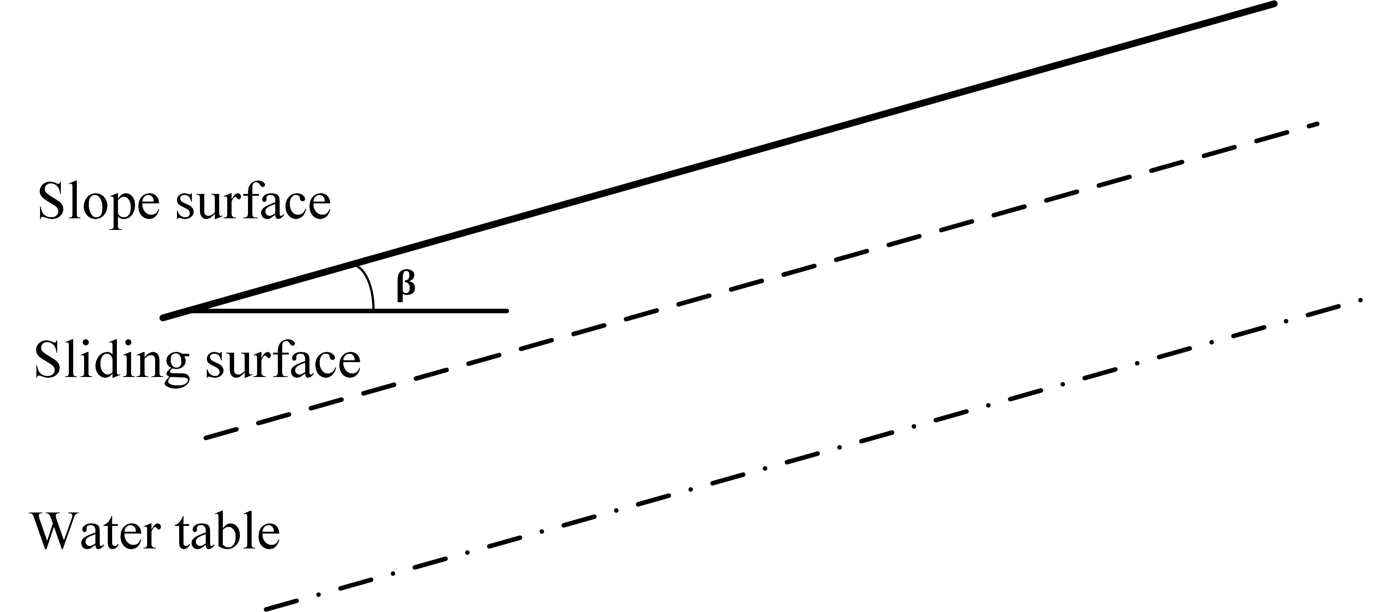

[fig:sm]

## Reinforcement soil model

In order to investigate the capacity of root system reinforcement soils, root reinforcement model which are capable of estimating the additional shear strength have been used in the research. One of the most the simple perpendicular root model Wu/Waldron(WWM) has been widely used to estimate the root cohesion.

### Fiber Bundle Model

developed the Fiber Bundle Model (FBM) to estimate root cohesion. FBM provides more accurate estimates of root reinforcement than Wu/Waldren model . FBM considers the fact that roots within the soil matrix have different maximum strengths, and therefore break at different points as a load is applied to the soil.

$$σ_{rj}=T_{rj}\frac{\sum_{i=1}^{j}{A_{i}}}{A_{s}}$$

where $A_{i}$ is the $i$

$$σ_{cr}=max(σ_{rj})$$

### Root tensile strength

To estimate the root additional cohesion $c_{r}$, we conducted the tensile strength tests using the tensile machine in the laboratory of Yunnan Agricultural University (Kumming, China). Before the experiment, the roots were immersed 24 hours in the water. The roots were washed and wiped off the excess water, which approximately recovered the state of the fresh roots. The roots were put in the fresh-keeping bag. The roots were taken from the fresh-keeping bag before the roots’ traction test was conducting.

Roots’ tensile resistance was measured using SN100 tensile strength tester (see Fig. [fig:tens]). The roots’ traction test with a constant displacement rate of 1mm/s was executed. The diameter of roots was measured using the digital vernier calipers.

The tensile strength of roots is defined as:

$$T_{r}=\frac{4F}{3.14D^{2}}$$

where $T_{r}(MPa)$ is the tensile strength of roots; $F(N)$ is the maximal force at the moment of the root’s break; $D(mm)$ is the diameter of root.

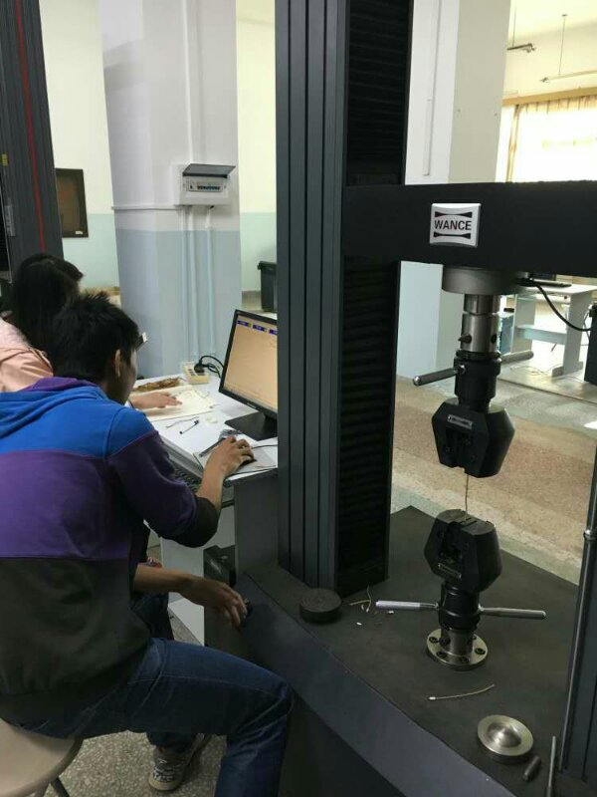

[fig:tens]

## Vegetated slope hydrological model

### Vegetated slope flow dynamic

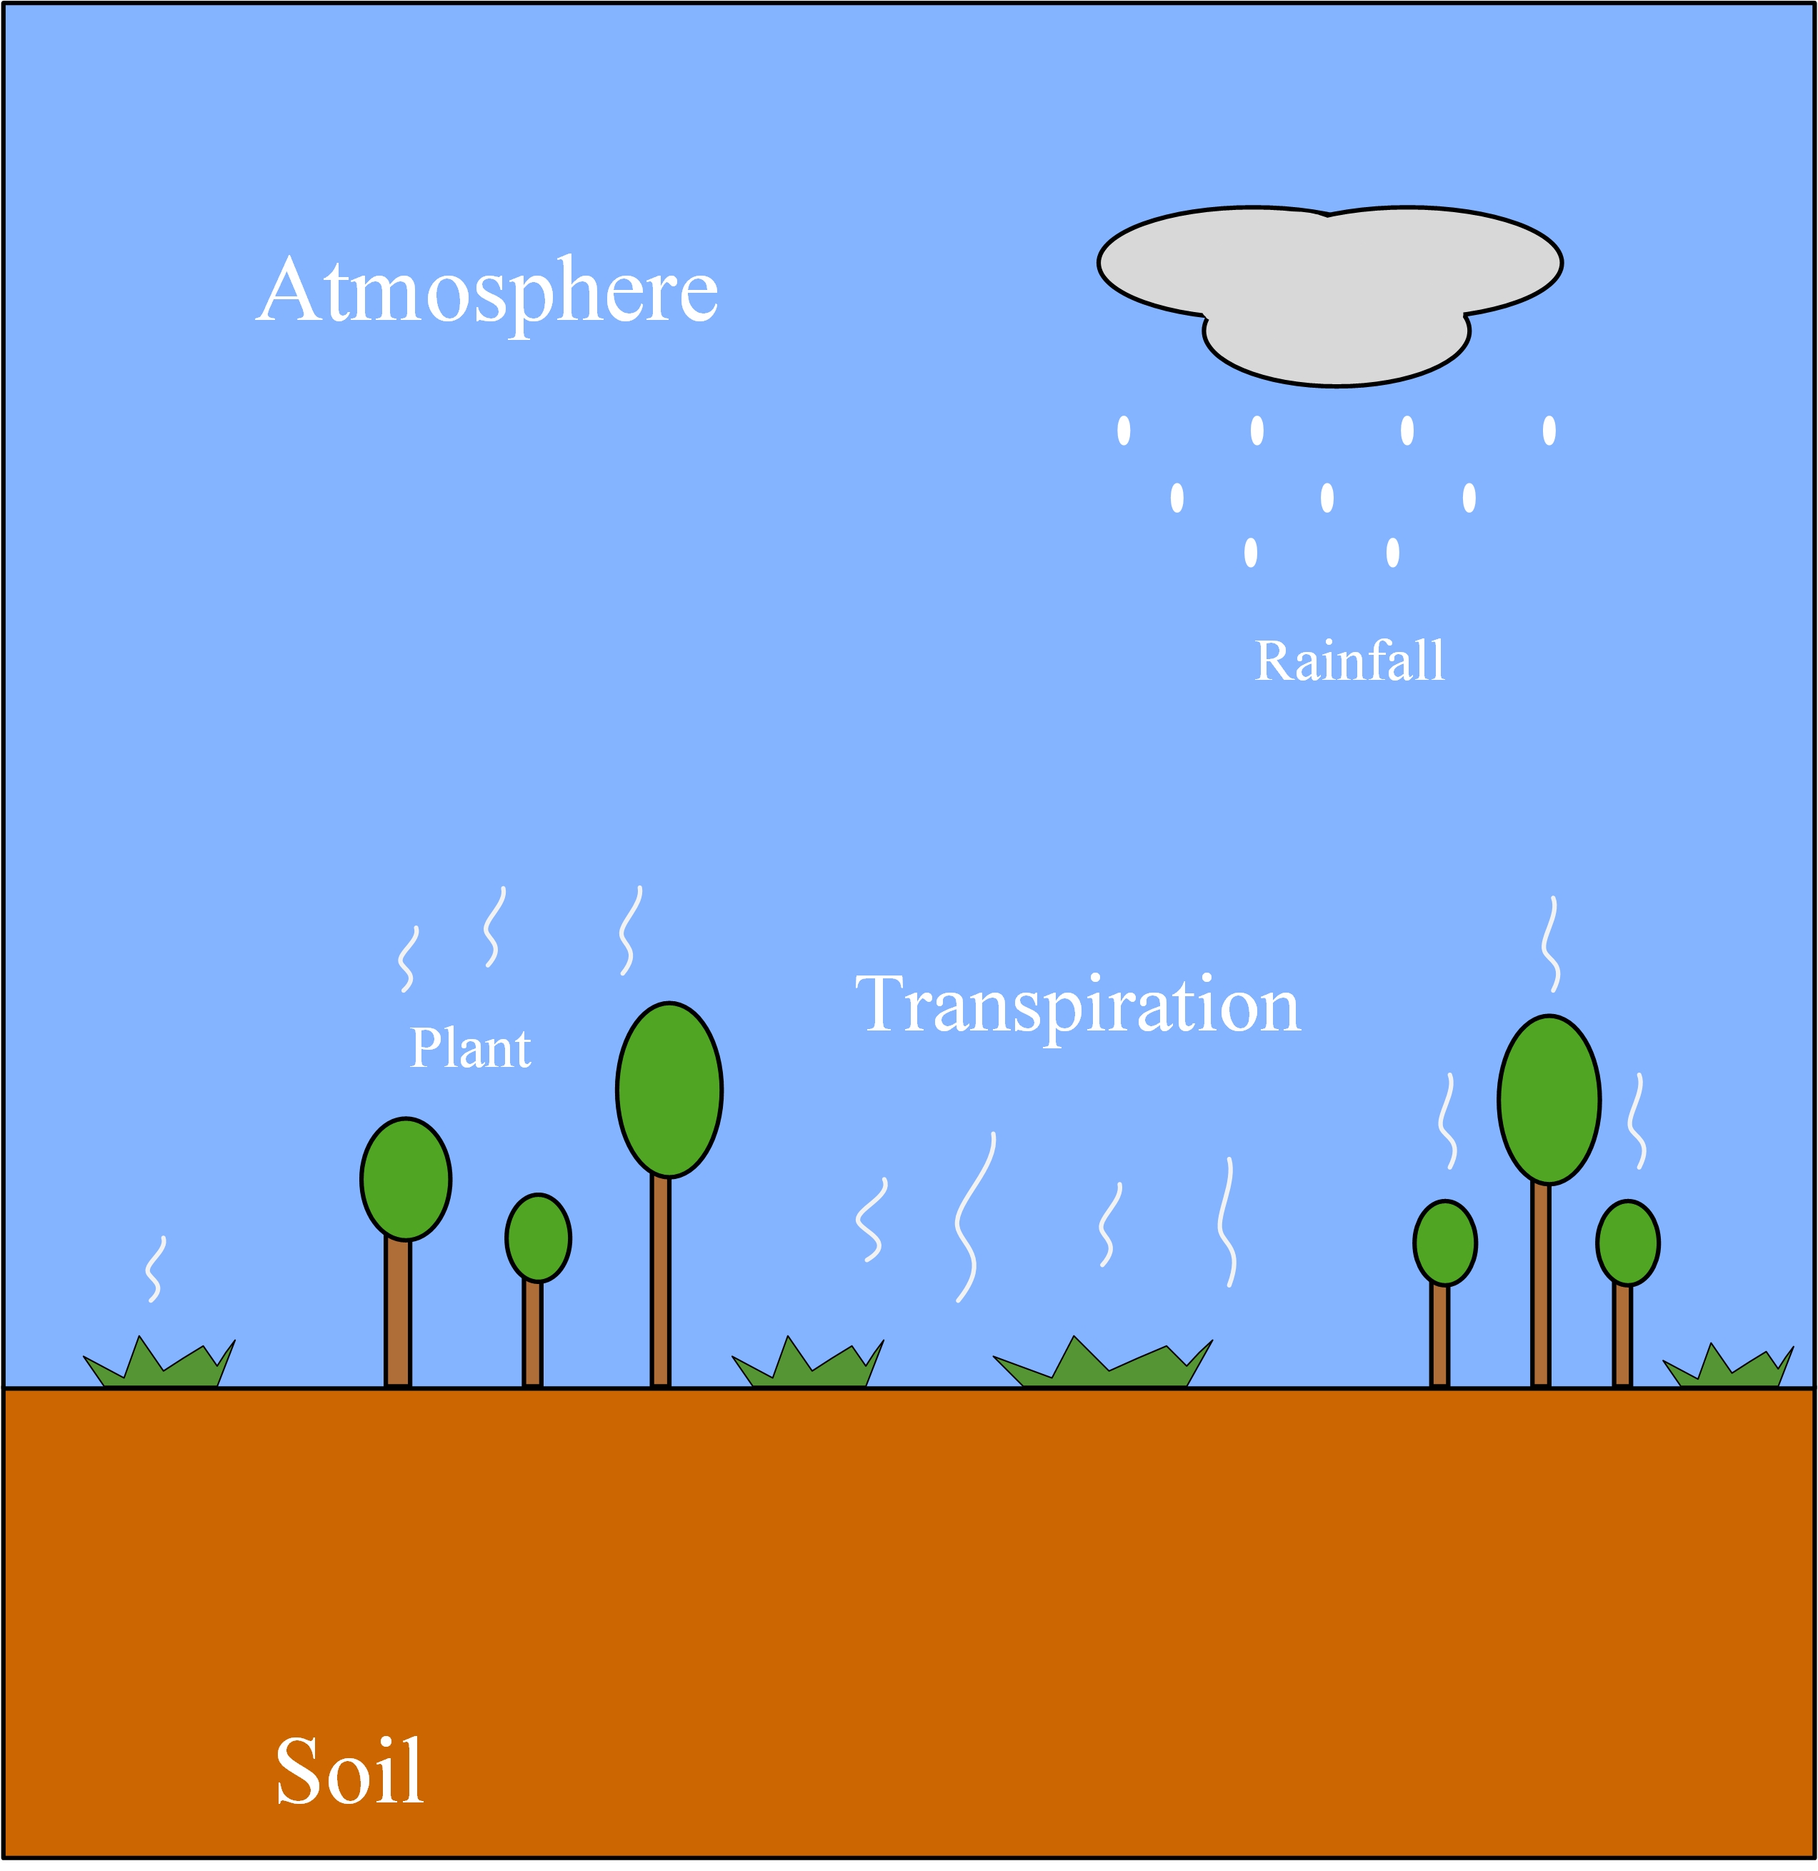

[fig:swap]

Evaportranspiration will reduce pore water pressure leading to increase in shear strength .

Soil hydrological behavior of vegetated slope can be studied using modified Richard’s equation and continuity equation, as follow:

$$\frac{∂θ}{∂t}=\frac{∂}{∂z}[K(h)\frac{∂h}{∂z}]+S(z)$$

where $θ$ is the soil moisture content; $t$ is the time; $K$ is the hydraulic conductivity; $h$ is the pressure head; $z$ is the vertical coordinate and $S$ is the sink terms.

### Sink terms

The vegetation transpiration is modeled using the water extraction from the roots, $S(z)$ is defined as:

$$S(z)=β(z)ξ(h)Etp$$

where $β(z)$ is the shape function of roots; $ξ(h)$ is the vegetation transpiration reduction function; $Etp$ is the maximum transpiration rate.

In the Ep. [2] $β(z)$ is defined by a shape function of roots. The shape function of roots can be defined as :

$$β(z)=\left\{\begin{matrix}β=\frac{1}{z_{r}} uniformly \\ \frac{2}{z_{r}}(1−\frac{z}{z_{r}}) triangularly\end{matrix}\right.$$

showed that uniform and triangular root distributions are not significantly different on the suctions retained, hence the uniformed distributed roots are considered in this study.

In this study, the function parameter $ξ(h)$ can be defined as:

$$ξ(h)=\left\{\begin{matrix}0 0≤h≤h_{1} \\ 1 h_{1}≤h≤h_{2} \\ 1−\frac{h−h_{1}}{h_{3}−h_{2}} h_{2}≤h≤h_{3} \\ 0 h_{3}≤h\end{matrix}\right.$$

### Evapotranspiration

Evapotranspiration from a vegetated slope system is affected by various factors, including soil moisture, solar radiation, soil heat capacity and plant type.

The actual transpiration rate, $E_{t}$, which is the sum of water uptake S(z) from the soil surface to the maximum root depth, $z_{r}$, is given by

$$\int_{0}^{zr}{S}(z)dz$$

### Soil water retention function

The soil water characteristic curve (SWCC) and hydraulic conductivity functions (HFC) are defined according to the

$$θ(h)=\left\{\begin{matrix}θ_{r}+\frac{θ_{s}−θ_{r}}{[1+(α|h|^{n})^{m})},h<0 \\ θ_{s},h≥0\end{matrix}\right.$$

where $θ(h)$ is the soil water content at a given suction head $h$; $h$ is the suction head; $θ_{s}$ is the saturated water content; $θ_{r}$ is the residual water content; $n$ and $m$ are the shape parameters, if n $>$ 1, then $m=1−\frac{1}{n}$

$$K(h)=\left\{\begin{matrix}K_{s}+\frac{1−(α|h|)^{n−1}[1+(α|h|^{n})]^{−m})^{2}}{[1+(α|h|^{n})^{m/2})},h<0 \\ K_{s},h≥0\end{matrix}\right.$$

where $K(h)$ is the hydraulic conductivity at a given suction heard $h$; $K_{s}$ is the saturated hydraulic conductivity.

## Model solution

A semi-implicit, a central finite-different scheme was applied to solve Eq.[3]

## Boundary and initial conditions

## Parameters used in the simulations

### Mechanical parameters

### Hydrological parameters

# Result

## Effects of root system on the slope stability

## Effects of slope geometry on the slope stability

## Sensitivity

# Discussion

# Conclusion

# Acknowledgment

# Appendix

The finite difference form of Eq.x can be written as follows:

$$\frac{θ_{i}−θ_{i}^{′}}{Δt}=\frac{D_{i+\frac{1}{2}}(θ_{i+1}−θ_{i})−D_{i−\frac{1}{2}}(θ_{i}−θ_{i−1})}{Δz^{2}}−\frac{K_{i+1}−K_{i−1}}{2Δz}−S_{r}$$

where $θ_{i}^{′}$ is the water content at initial time, $θ_{i}$ is the water content at the end of period.

A differential equation is written for each node and an algebraic equation is obtained.

$$\left[\begin{array}{ccccc}
b_1 & c_1 & $$$$ & $$$$ & $$$$ \\
a_2 & b_2 & c_2 & &\\
.&.&.&&\\
&.&.&.&\\
&&.&.&.\\
&&a_{n-1}&b_{n-1}&c_{n-1}\\
&&&b_{n}&c_{n}\\
\end{array}\right]
\left[\begin{array}{c}
\theta_1\\
\theta_2\\
.\\
.\\
.\\
\theta_{n-1}\\
\theta_{n}\\
\end{array}\right]
=
\left[\begin{array}{c}
H_1\\
H_2\\
.\\
.\\
.\\
H_{n-1}\\
H_{n}\\
\end{array}\right]$$

$$\left\{\begin{matrix}a_{i}=r_{1}D_{i−\frac{1}{2}}, i=2,3,...n \\ b_{i}=−[1+r_{1}(D_{i−\frac{1}{2}+D_{i+\frac{1}{2}}}], i=2,3,...n \\ c_{i}=r_{i}D_{i+\frac{1}{2}}, i=2,3,...n−1 \\ H_{i}=r_{3}(K_{k+1}−K_{i−1}−θ_{i}^{​}), i=2,3,...n−1\end{matrix}\right.$$

$$\left\{\begin{matrix}b_{1}=1+2r_{1}D_{1+\frac{1}{2}} \\ c_{1}=−2r_{1}D_{1+\frac{1}{2}}\end{matrix}\right.$$